Hindi Vidya Prachar Samiti’s
RAMNIRANJAN JHUNJHUNWALA COLLEGE OF ARTS, SCIENCE AND COMMERCE
(EMPOWERED AUTONOMOUS)

Data Engineering



Name: Surajkumar Yadav
Roll no: 10302
Class: MSc. Data Science and Artificial Intelligence Part I


Ramniranjan Jhunjhunwala College
of Arts, Science and Commerce

Department of Data Science and Artificial Intelligence

CERTIFICATE

This is to certify Surajkumar Yadav of MSc. Data Science and Artificial Intelligence Roll No 10302 has successfully completed the practical of Data Engineering during the Academic Year 2024-2025.
Date:

(Prof. Neha Ansari ) External Examiner
Prof-In-Charge

INDEX

Sr. No. | Practical | Date | Sign
1 | - Data Extraction Using Web Scraping  - Perform data extraction from xml file to dataframe/csv | 20/01/2025
2 | Create ML pipeline(workflow) using python libraries | 20/01/2025
3 | Working with NoSQL database - HBase | 13/02/2025
4 | Simulating Datawarehouse environment | 17/02/2025
5 | - Working with different types of tables in hive  - Demonstrating table partitioning, clustering (Bucketing in hive) | 20/02/2025
6 | Demonstrating Publisher/Subscriber messaging system using Kafka | 03/03/2025
7 | - Write a simple PySpark Driver Program  - Working with different transformation and actions on RDD by fetching data from an external file | 04/03/2025
8 | Data Exploration using Spark SQL | 06/03/2025

Practical 1-A: Data Extraction Using Web Scraping

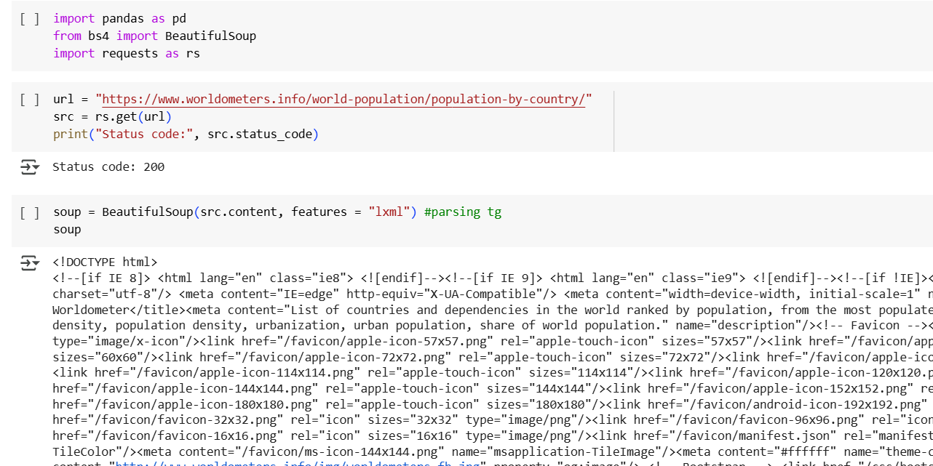
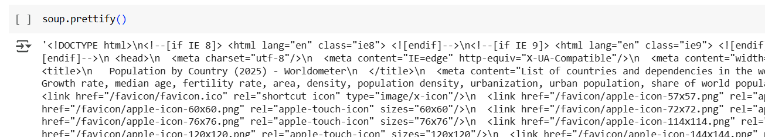
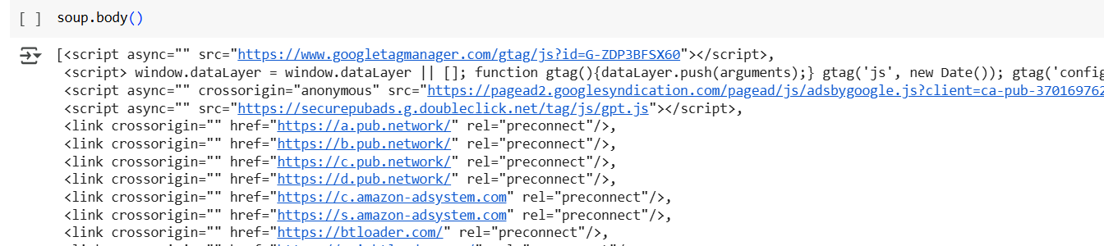
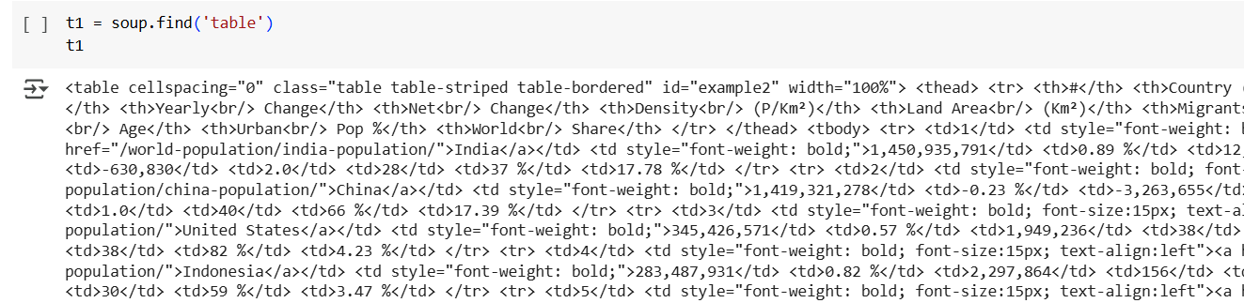
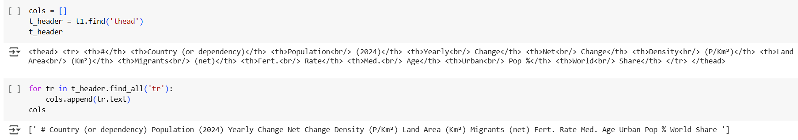
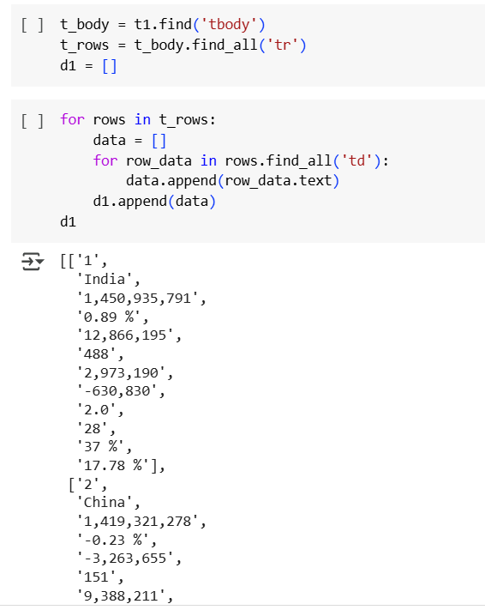
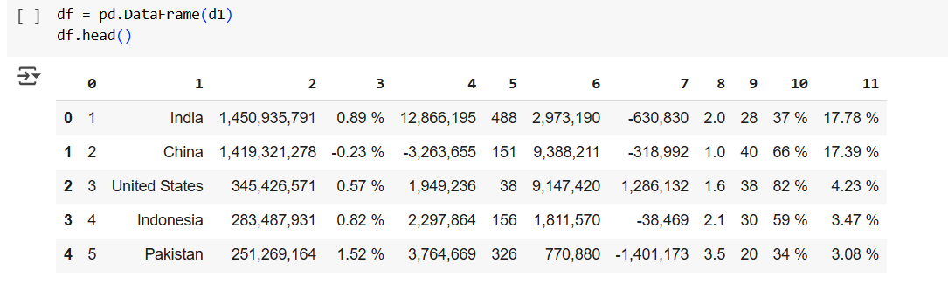

Practical 1-B: Perform data extraction from xml file to dataframe or CSV

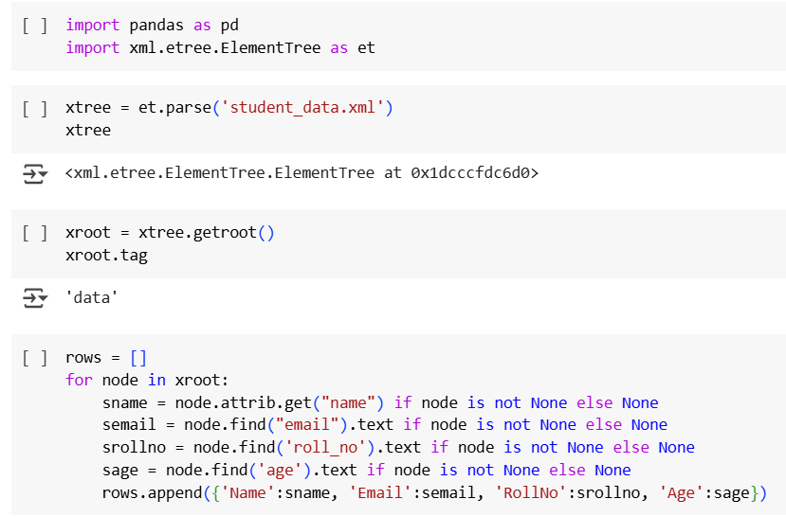
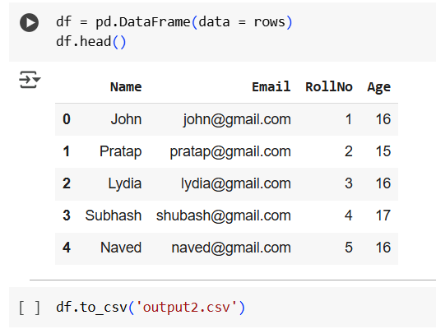

Practical-2 Create ML pipeline(workflow) using python libraries

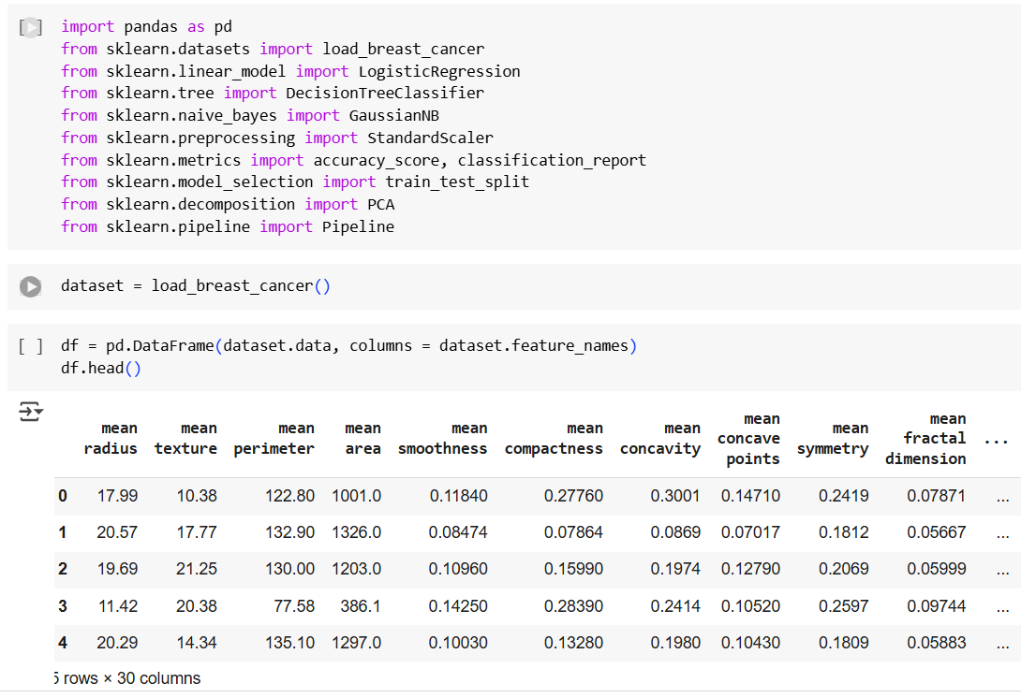
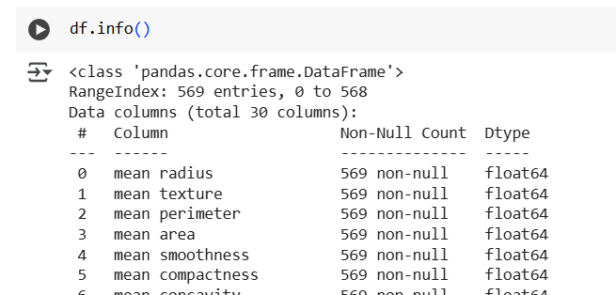
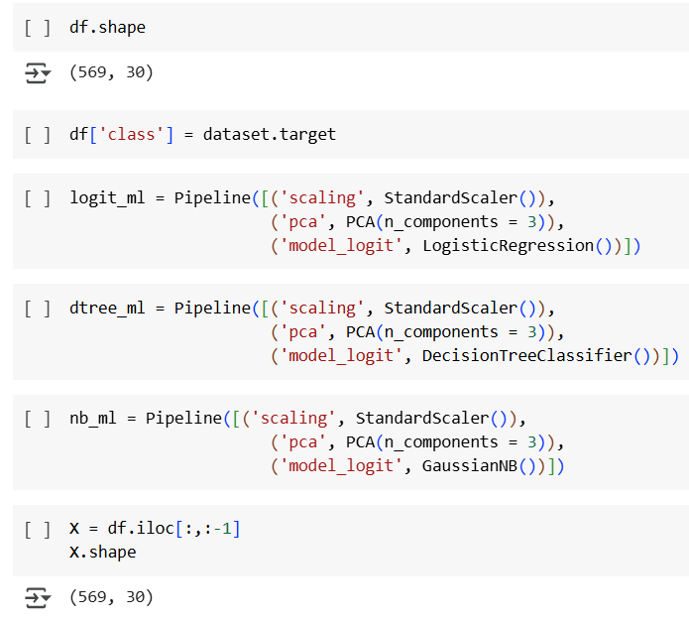
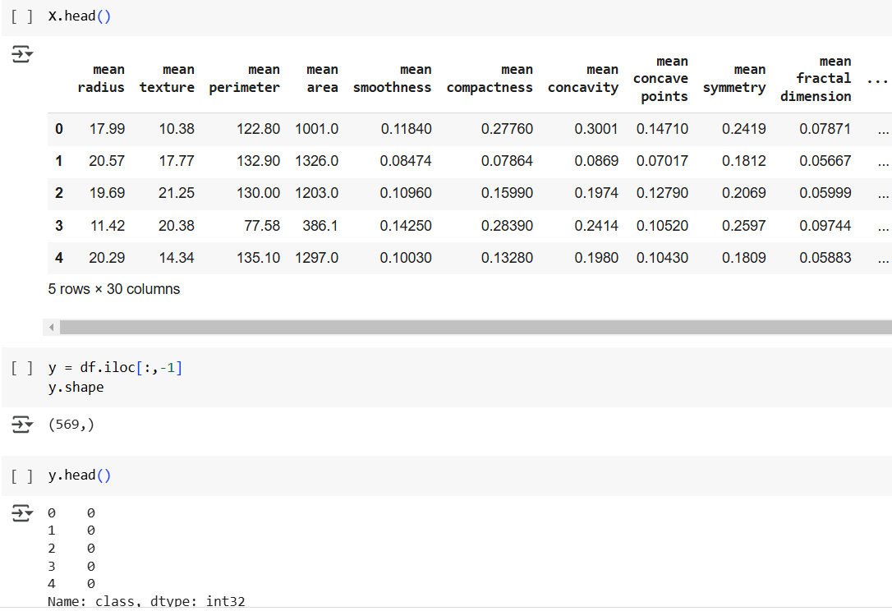
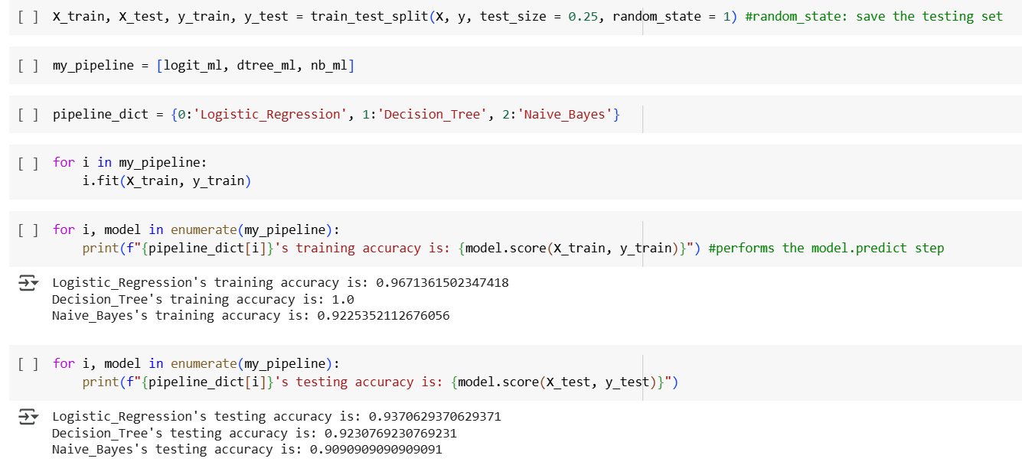
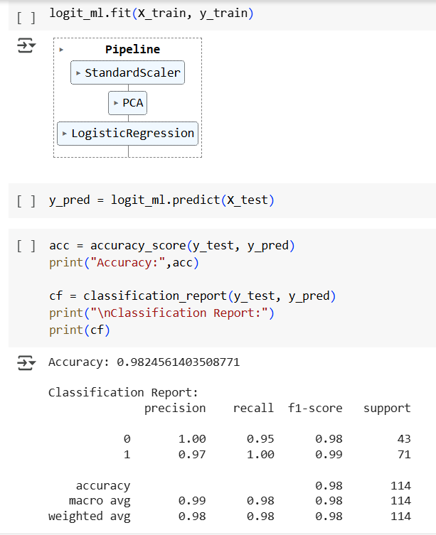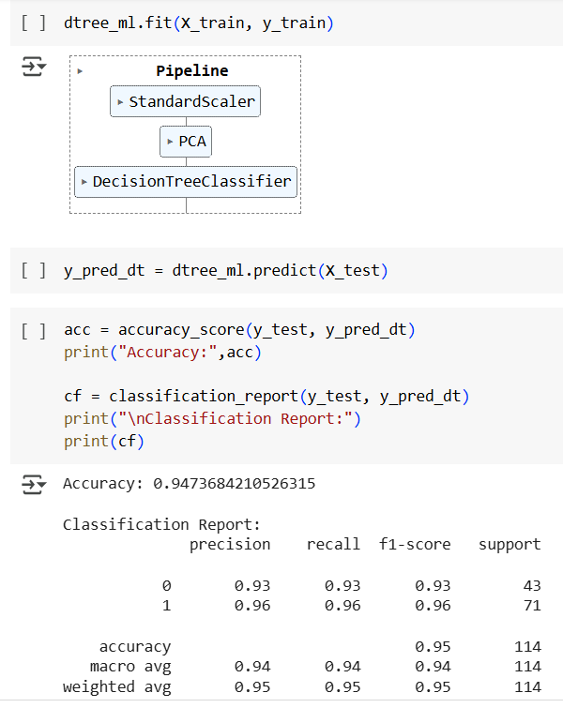

Practical :3 Working with NoSQL database – HBase

Creating a LinkShare in HBase / using the existing one.
> hbase shell
> create ‘studentrj’, ‘studid’, ‘studname’, ‘studaddress’
> describe ‘studentrj’
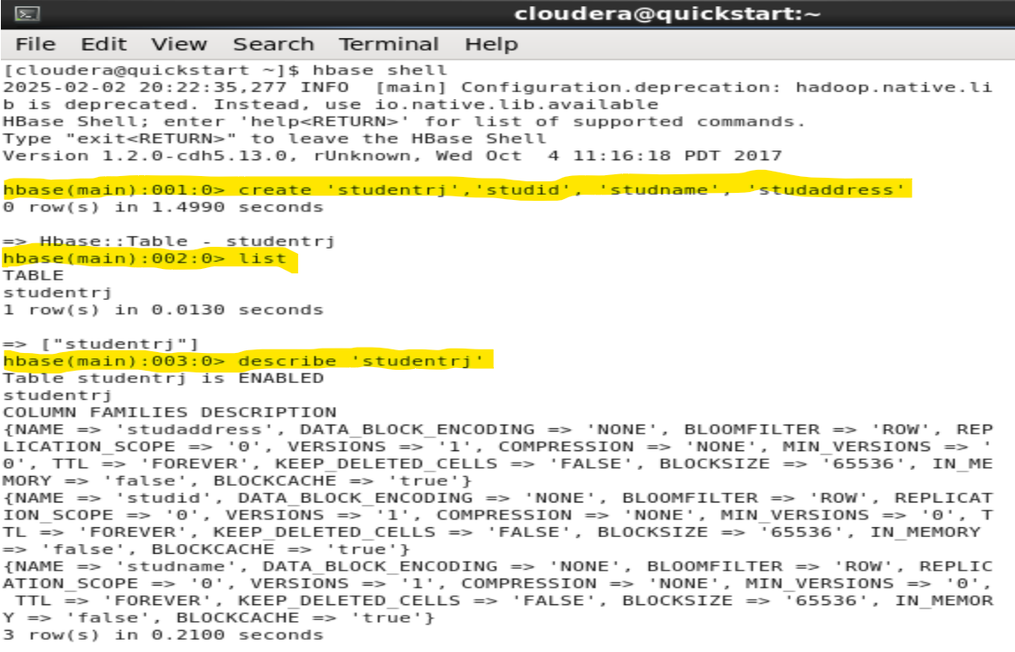
Inserting the values in the linkshare
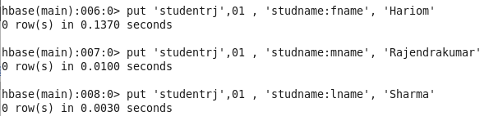
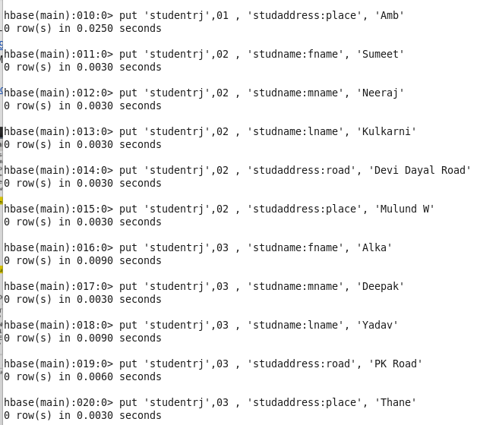
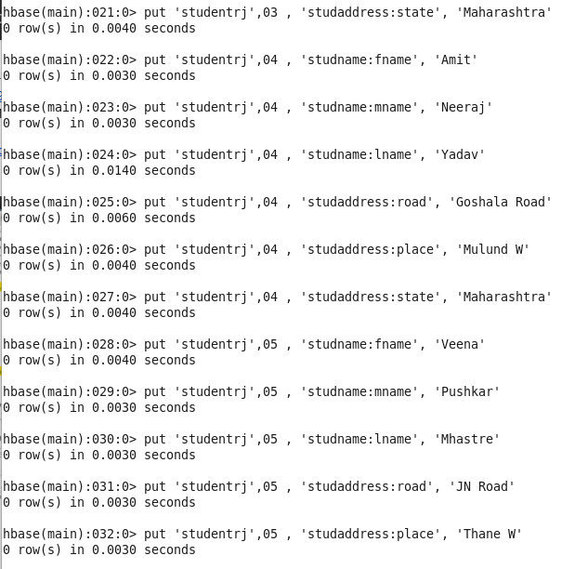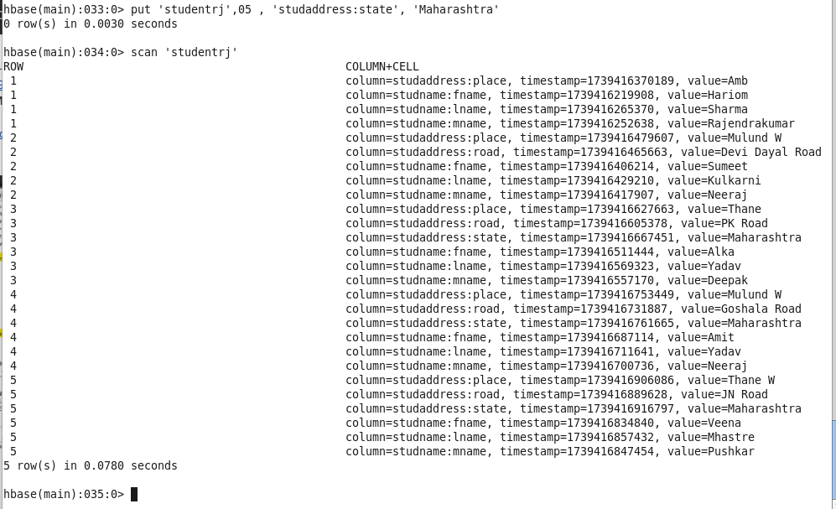

Q 1: Get the value for column place for studid 1 using column keyword
>get ‘studentdata’ , ‘1’ ,{COLUMN => ‘studentaddress : place’ }
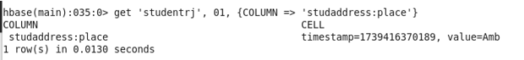

Q 2: Retrieve all column values for studid 1
>get ‘studentdata’ , ‘1’
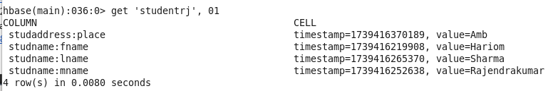

Q3: get all the record for studid 2, 3, 4

>get ‘studentdata’ , ‘02’
>get ‘studentdata’ , ‘03’
>get ‘studentdata’ , ‘04’

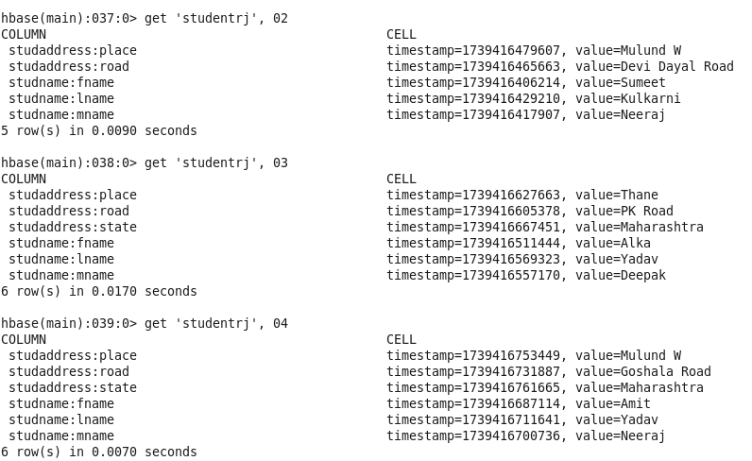

Q4: get all the column values for column family studaddress for studid 1 without using column keyword
>get ‘studentdata’ , ‘1’ , ‘studaddress’
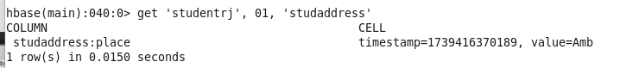
Q5: change the last name for studid 1 from vaze to Kelkar and check the record to see if the change are done
>put ‘studentdata’ , ‘1’ , ‘studname:lname’ , ‘Kelkar’
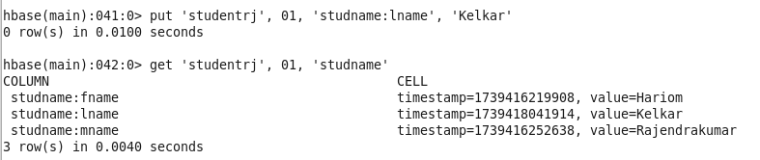

# Perform the following processes on student table
- Count the number of records
>count ‘studentdata’
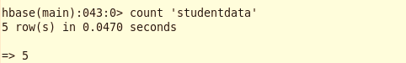

- Disable the table
>disable studentdata’
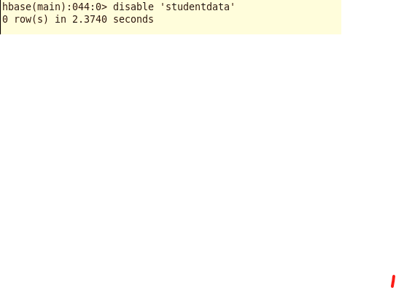

- Verify if the table is disabled
>is_disabled ‘studentdata’
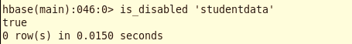

- Enable the table again and scan the table
>enable ‘studentdata’
>scan ‘studentdata’
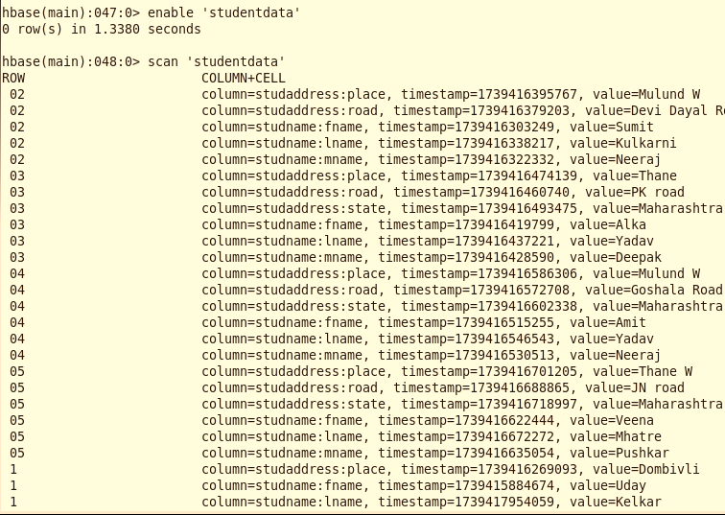

- Delete the column middle name for student with id 4
>delete ‘studentdata’ , ‘04’ , ‘studname : mname’

- Delete all the column families and columns for record 4
>deleteall ‘studentdata’ , ‘04’
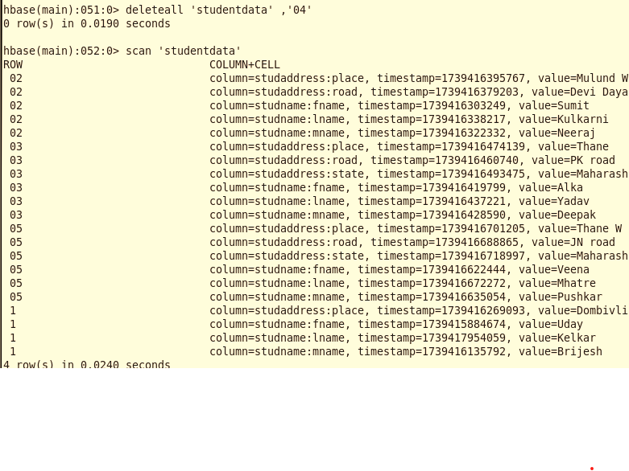

- Set the maximum number of cell changes for the student address column family to 5
>alter ‘studentdata’ , NAME => ‘studaddress’ , VERSIONS =>5
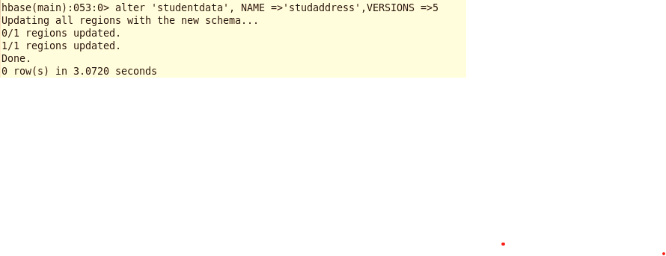
- Delete column family student address from student table
>alter ‘studentdata’ , ‘delete’ => ‘studaddress’
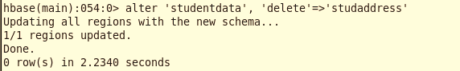

- Check if the student table exists using exists and list keywords, now drop table student and again check if the student exists
>exists ‘studentdata’
>list
>disable ‘studentdata’
> drop ‘studentdata’
>list
>exists ‘studentdata’
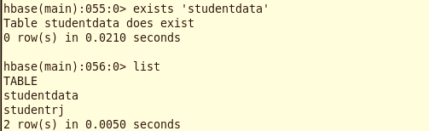
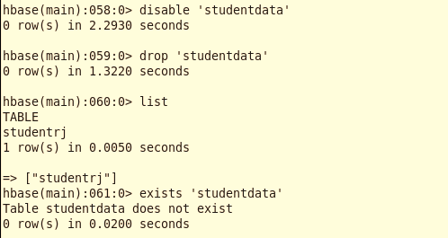

Practical 4: Simulating the Datawarehouse environment
Part-1
Q1: Create a Datawarehouse database names college1
>hive
>create database college1 ;
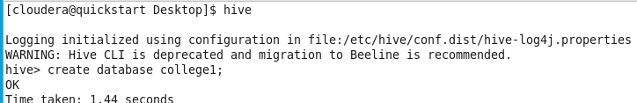

Q2: check the creation of the database
>show databases ;
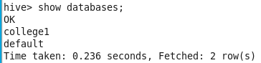

Q3: In the table create columns of roll_no, name, course and marks, the fields in the table must be separated by ‘,’.
> use college1 ;
> create table student ( roll_no int , name string ,
Course string , marks float)
row format delimited fields terminated by ‘,’ ;
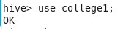

Q4: create a txt file in Hadoop cluster and load the data from the txt file in the student
table
>exits ;
>gedit studentdata1.txt

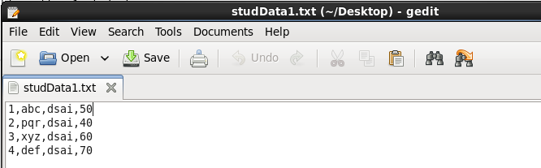

>hdfs dfs -mkdir /hadoop1
> hdfs dfs -mkdir /hadoop1/data
> hdfs dfs -put studentdata1.txt /hadoop1/data
> hdfs dfs -ls

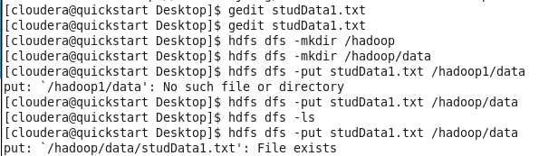

Q5: display the data in the student table
>hive
> use college1;
> describe formatted student ;
> load data inpath ‘/hadoop1/data/studentdata1.txt’ into table student ;
> select * from student ;

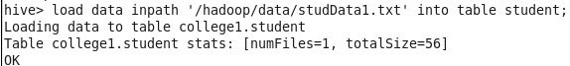
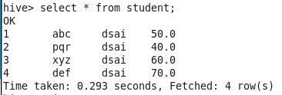

Part-2
Q1: create a csv file to store the data of insurance policy customers and enter some data
>gedit customer.csv

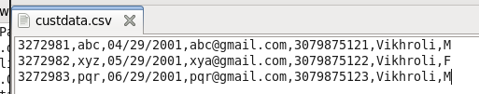

Q2: create a database name licdw and inside that create a table named customer having column id, name, dob, email-id, contact no, address and gender
>hive
> create database licdw;
> show databases;
> use licdw;
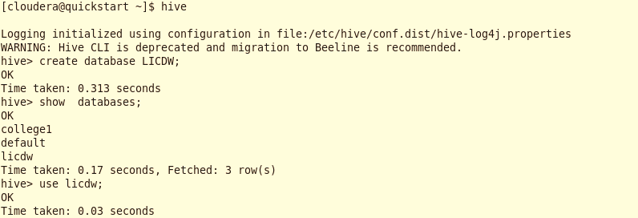
> create table customer ( id int,
name string, dob string,
email string, contactno string ,
address string, gender string)
row format delimited fields terminated by ‘,’ ;
>show tables ;
> describe customer;

Q3: load the data from the csv file to customer table
>load data local inpath ‘/home/cloudera/customer.csv’ into table customer ;
>select * form customer ;

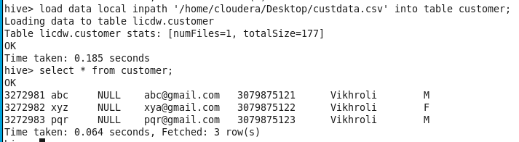

Practical 5 A: Working with different types of tables in hive
Internal Table:
>hive
> create database licdw;
> show databases;
> use licdw;
> create table customer ( id int,
name string, dob string,
email string, contactno string ,
address string, gender string)
row format delimited fields terminated by ‘,’ ;
>show tables ;
> describe customer;

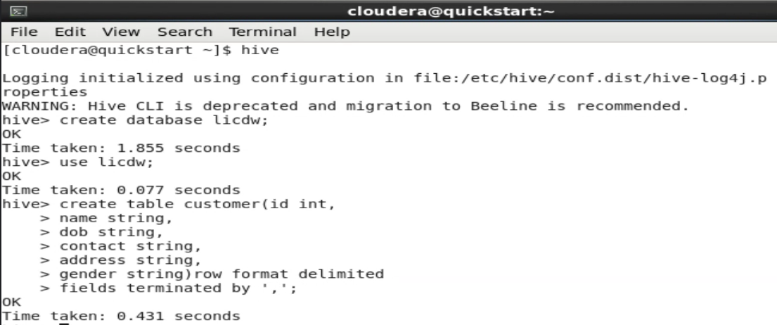
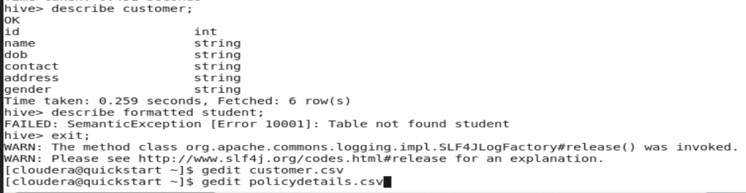
>load data local inpath ‘/home/cloudera/customer.csv’ into table customer ;
>select * form customer ;
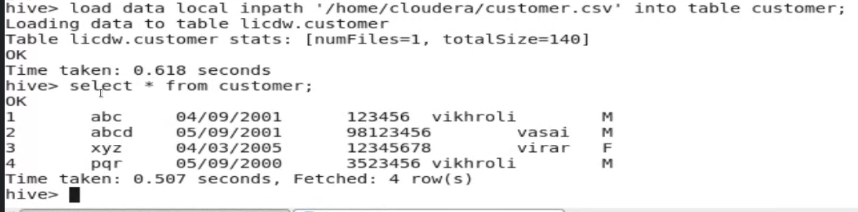

External Table:
>gedit policydetails.csv
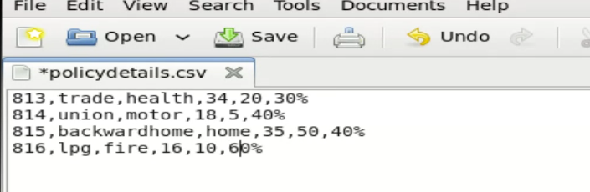
>create external table policy_details (id int ,
name string,
type string,
age_criteria int,
tenure int ,
maturity string) row format delimited fields terminated by ‘,’
stored as textfile location ‘/home/cloudera/policy_detail_data’ ;
>load data local inpath ‘/home/cloudera/Desktop/policydetails.csv’ into table policy_details;
> select * from policy_details ;

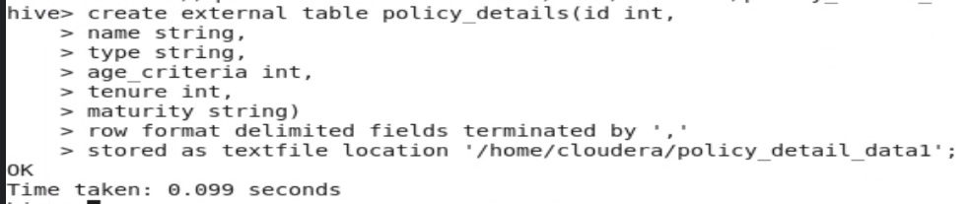
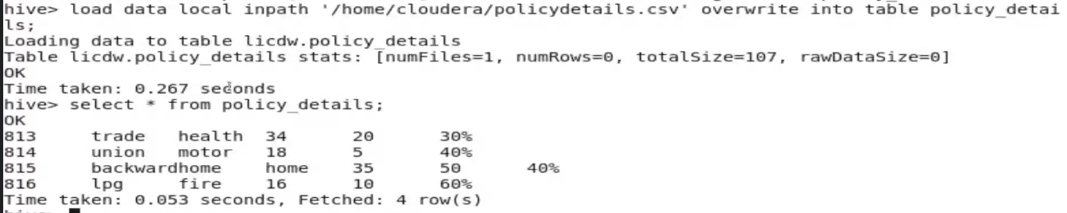
>hdfs dfs -ls hdfs://quickstart.cloudera:8020/home/cloudera/policy_detail_data
> hdfs dfs -cat hdfs://quickstart.cloudera:8020/home/cloudera/policy_detail_data/policydetails.csv
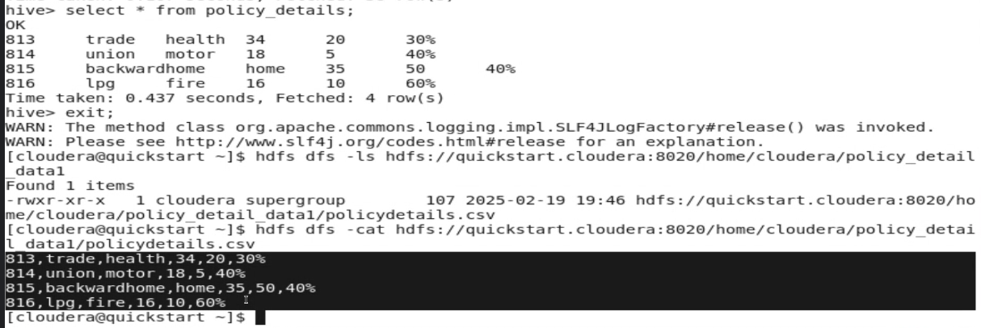

Temp Table :
>create temporary table policy_details_temp ( id int,
name string,
type string,
age_criteria int ,
tenure int,
maturity string)
> describe policy_details_temp ;
> insert into policy_details_temp values (32, ‘abc’ , ‘h’ , 32 , 3 , ‘40%’);
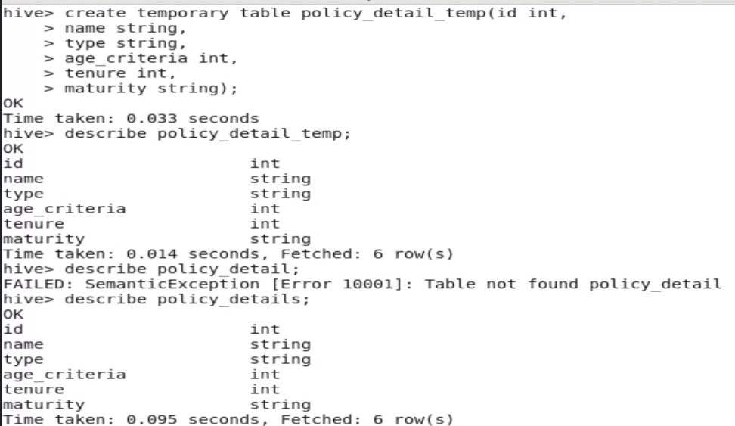
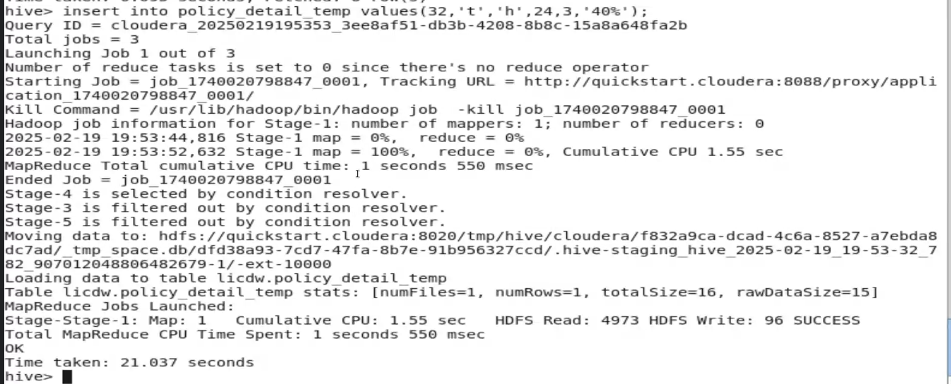
>select * from policy_details_temp;
> show tables ;
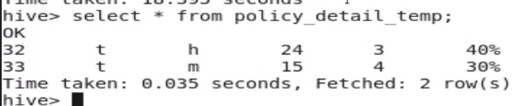
Close the existing hive session and open a new hive session
>use licdw;
>show tables
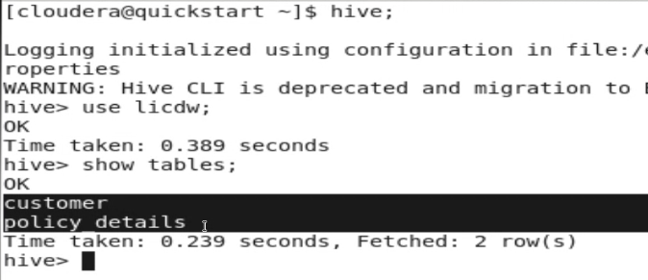

Practical 5 B: Demonstrating table partitioning and clustering (bucketing in hive)
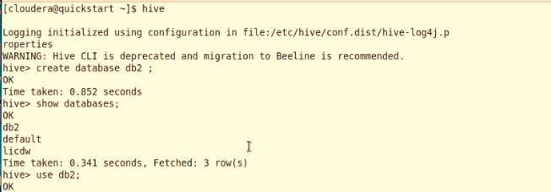
Q1: create end partition a table named emp_partition on the mobile_no column and load data into it
> create table emppartition( emp_id int ,
name string ) partitioned by (m_no string)
row format delimited fields terminated by ‘,’ ;
> set hive.exec.dynamic.partition.mode = nonstrict;
> insert into emppartition partition(m_no) values (1, ‘sam’ , ‘123455667’) ;

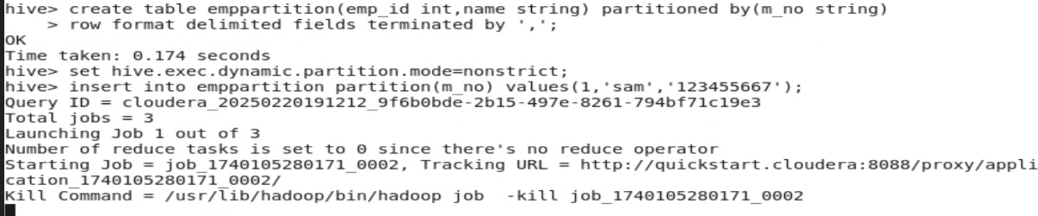
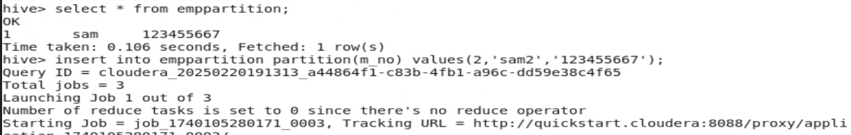
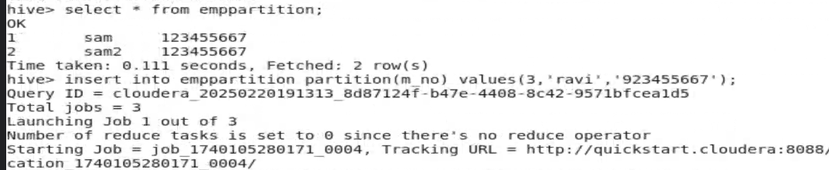
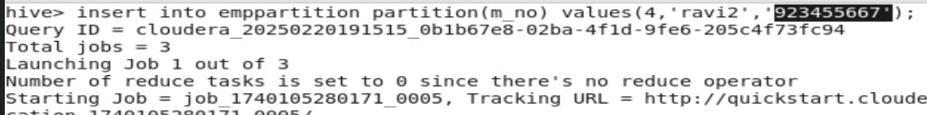
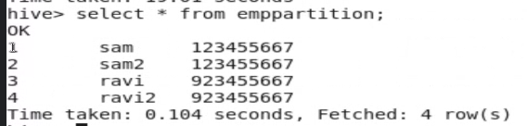

Q2: create a table empbucknopartition with only bucketing on the mobile no. column load data into it
> create table emp_buck_no_partition( emp_id int , name string , m_no string)
clustered by(m_no) into 5 buckets ;
> insert into emp_buck_no_partition values(1 , ‘xyz’ , ‘12344555’) ;
> select * from emp_buck_no_partition ;

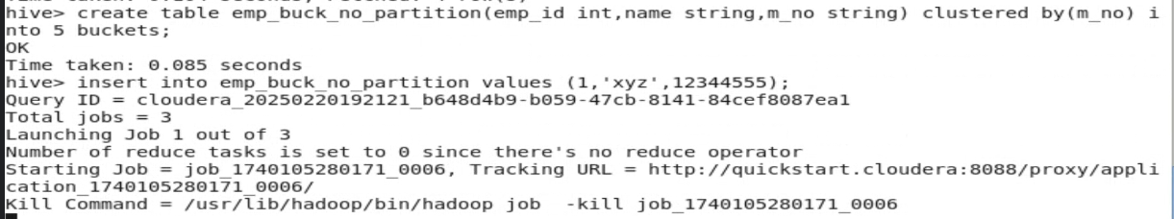
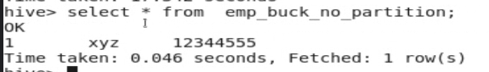

Q3: Create a table named emp_buck_with_partition on m_no2. column and load data into it
> create table emp_buck_with_partition ( emp_id int , name string , m_no string)
partitioned by (m_no2 string) clustered by(m_no) into 5 buckets ;
> set hive.exec.dynamic.partition.mode = nonstrict ;
> insert into emp_buck_with_partition partition(m_no2) values(1, ‘abc’ , ‘2345667’ , ‘1234455’ ) ;

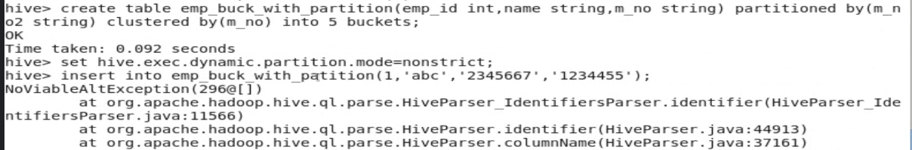
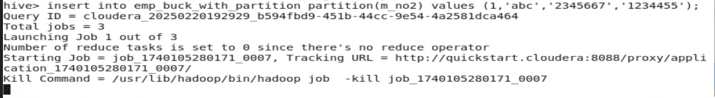
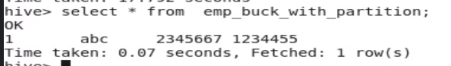

Practical 6: Demonstrating Publisher/Subscriber messaging system using Kafka

Next the setup for Kafka: first create a folder named Kafka in your C drive
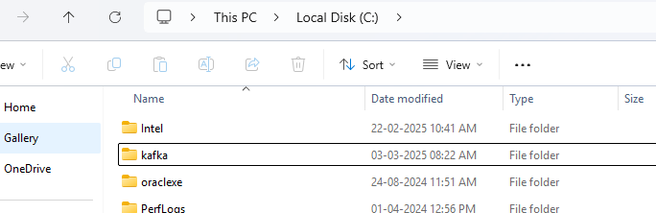
And unzip the kafka_2.12-2.4.1.tgz files in to the newly created kafka folder in c drive
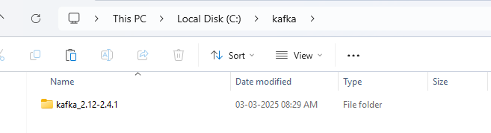

Open the folder kafka_2.12-2.4.1 and select all the files and click on cut
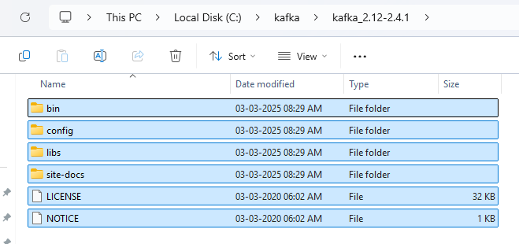

Then go back to the c:\kafka directory and paste the files
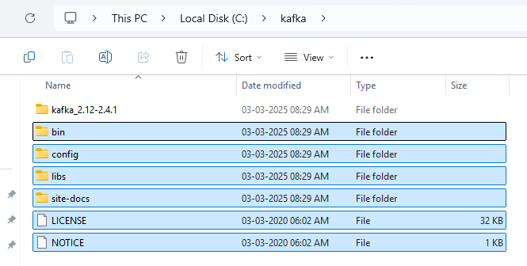

At last delete the delete the kafka_2.12-2.4.1 folder as it will be empty since we removed the data from it

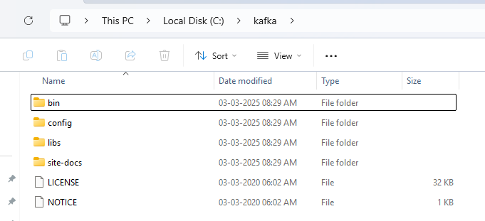

Next click on the config folder , here you will find two properties files named server.properties and zookeeper.properties
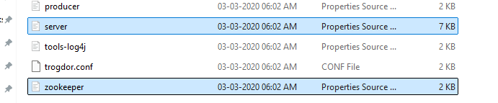

Open the zookeeper.properties by any text editor on line number 16 you will see a dataDir=/tmp/zookeeper. We need to replace the /tmp with out kafka path that is C:\kafka\ and after the zookerper put -data , save and exit
So it will look like the below image :
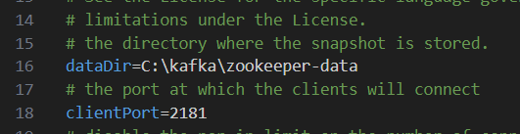

Similarly open the server.properties file on line no 60 do the changes on logs.dirs as show below in image : Save and exit after the changes
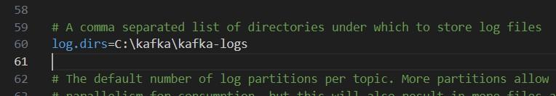

Next open the power shell and change the directory to the kafka folder in C drive :
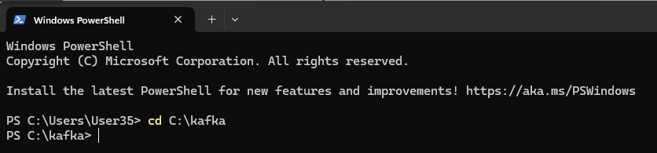

Next write the command .\bin\windows\zookeeper-server-start.bat .\config\zookeeper.properties and click on enter
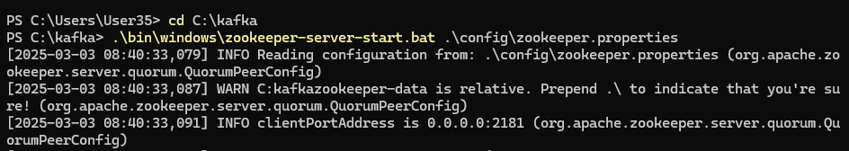

Now minimize this powershell (Do not click on cut) and open a new power shell with same path of C:\kafka And write the command: .\bin\windows\kafka-server-start.bat .\config\server.properties and enter
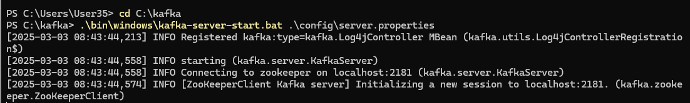
Now while this 2 powershells are running in the background go the C drive kafka folder in that \bin in that \windows and open a cmd from that
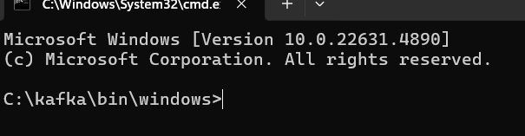

And run the command kafka-topics.bat --create --bootstrap-server localhost:9092 --replication-factor 1
--partitions 1 --topic test
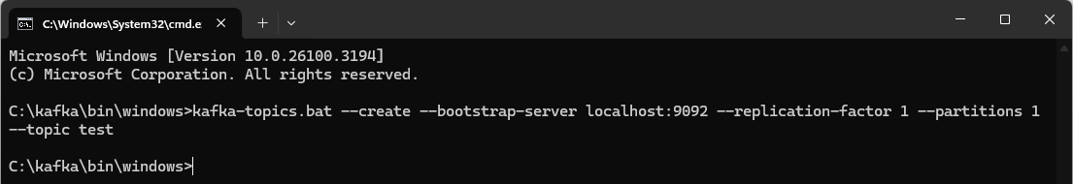

Now open two new cmd with same location as the c:\kafka\bin\windows :
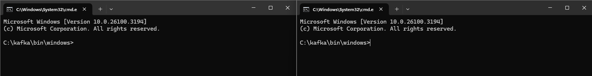

In one cmd type the command : kafka-console-producer.bat --broker-list localhost:9092 --topic test
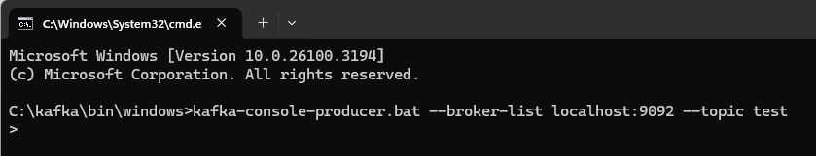

And in the second cmd type the command : kafka-console-consumer.bat --bootstrap-server localhost:9092--topic test --from-beginning
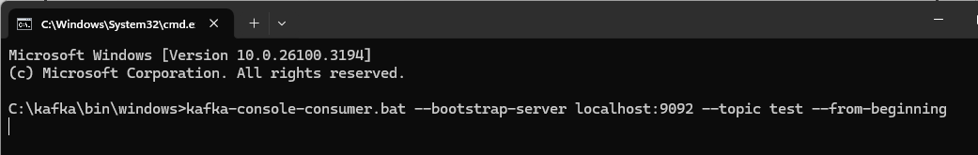

Now if we pass some string form the first cmd that has > ( > Kafka practical) it will display the data in the 2nd cmd :
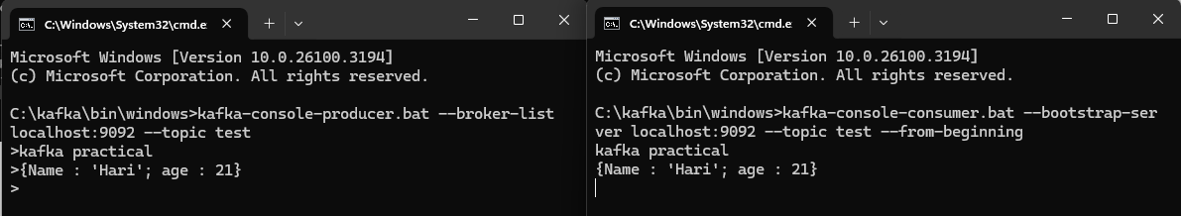

Practical 7: Write a simple Pyspark driver program
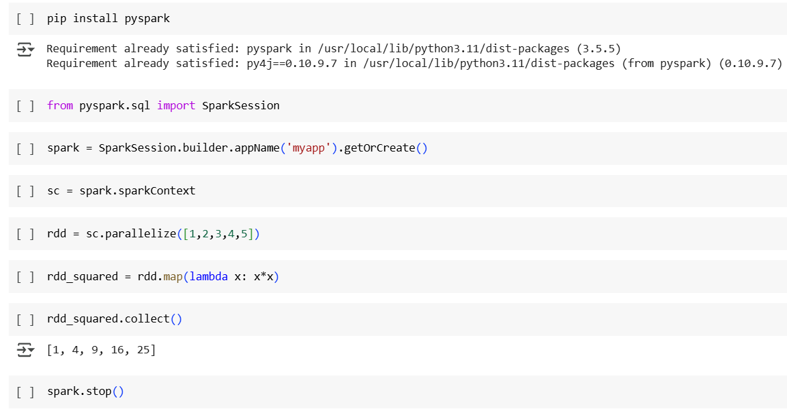
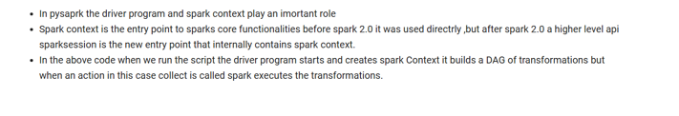

Practical 7 B: Working with different transformations and actions on RDD by fetching data from an external file
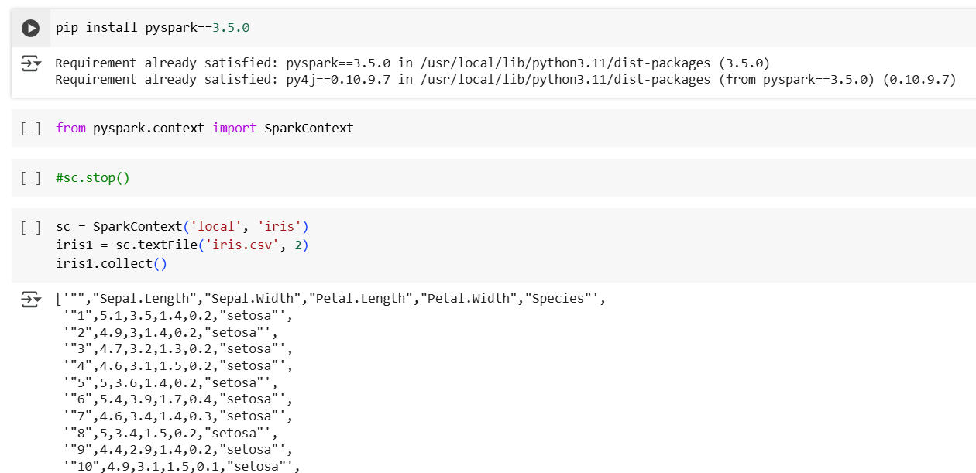
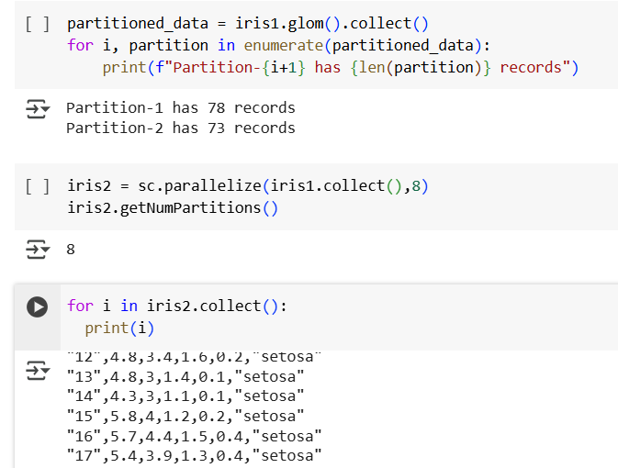
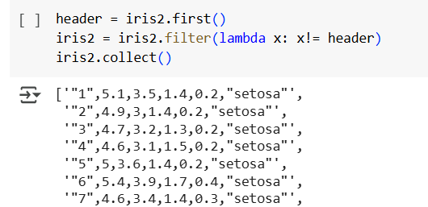
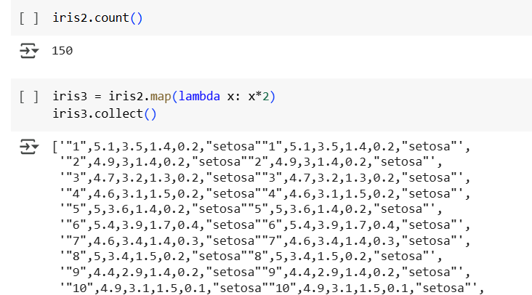

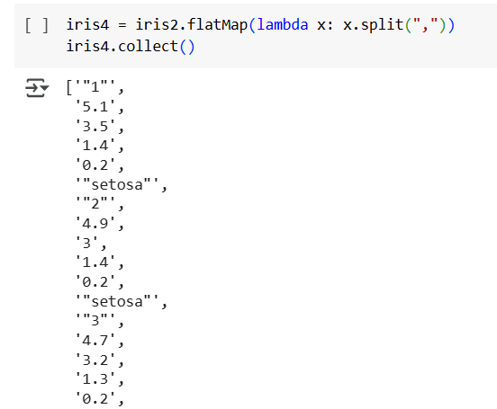
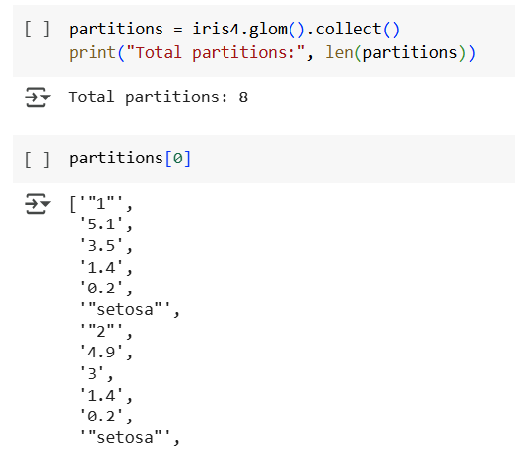
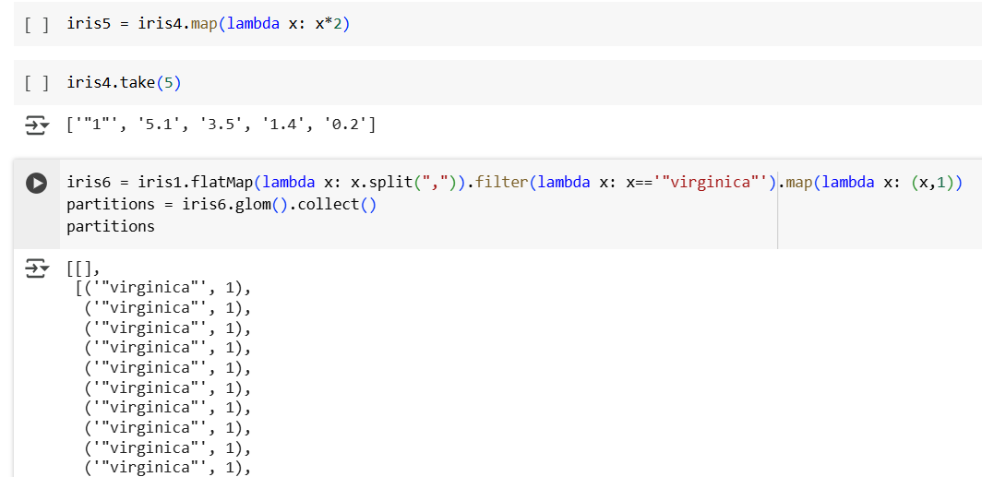
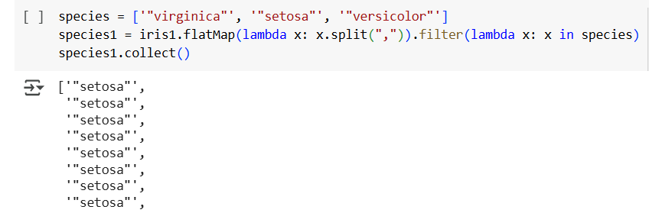
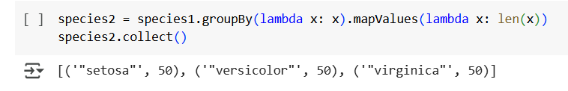

Practical 8: Data Exploration using Spark SQL
